Inverted Pendulum PID Demonstrator

Project Development Plan (PDP)

Matt Handley, Joseph Sedutto, Austin Cardosi, Kathryn Swineford

Southern New Hampshire University

# Abstract

Abs

## 

# Table of Contents

**Abstract** **2**

**Table of Contents** **3**

**The System Description** **5**

Problem Statement 5

Design Research 5

- Rotary Inverted Pendulum 5

- Reaction Wheel Inverted Pendulum 5

- Technical Challenges 6

Customers/markets/economics/applications 6

Stakeholders 6

Use 6

**ConOps Summary** **6**

System Description 6

**System Requirements (Top Level)** **7**

Functional Requirements: (what it does) 7

Performance Requirements: (how well it does) 7

Physical Requirements: (sizes, weight) 8

Environmental and Safety Requirements: 9

Engineering Standards Applied: 9

**Risk Assessments** **10**

Risk Assessment 10

**Design Concepts** **11**

Sketches 11

System Composition Block Diagram 12

Flow Chart of Operations 12

Health and Safety Design Features: 12

Global and Environmental Design Features: 12

Used Engineering Standards: 12

**Task Plan** **13**

**Budget** **14**

**References** **14**

## 

# The System Description

## Problem Statement

The goal is to make a PID Demonstrator that is intuitive for all age groups to demonstrate how to use a PID loop and what each individual variable does to effect a vertical standing pendulum.

## Design Research

#### Rotary Inverted Pendulum

* + Inverted pendulum that spins about a fixed axis.
  + The combination of motors and sensors allow the pendulum to stabilize itself upright.
  + Based on the pendulum angle the motor can accelerate in both directions to counterbalance the falling rod.
  + $200 - $500

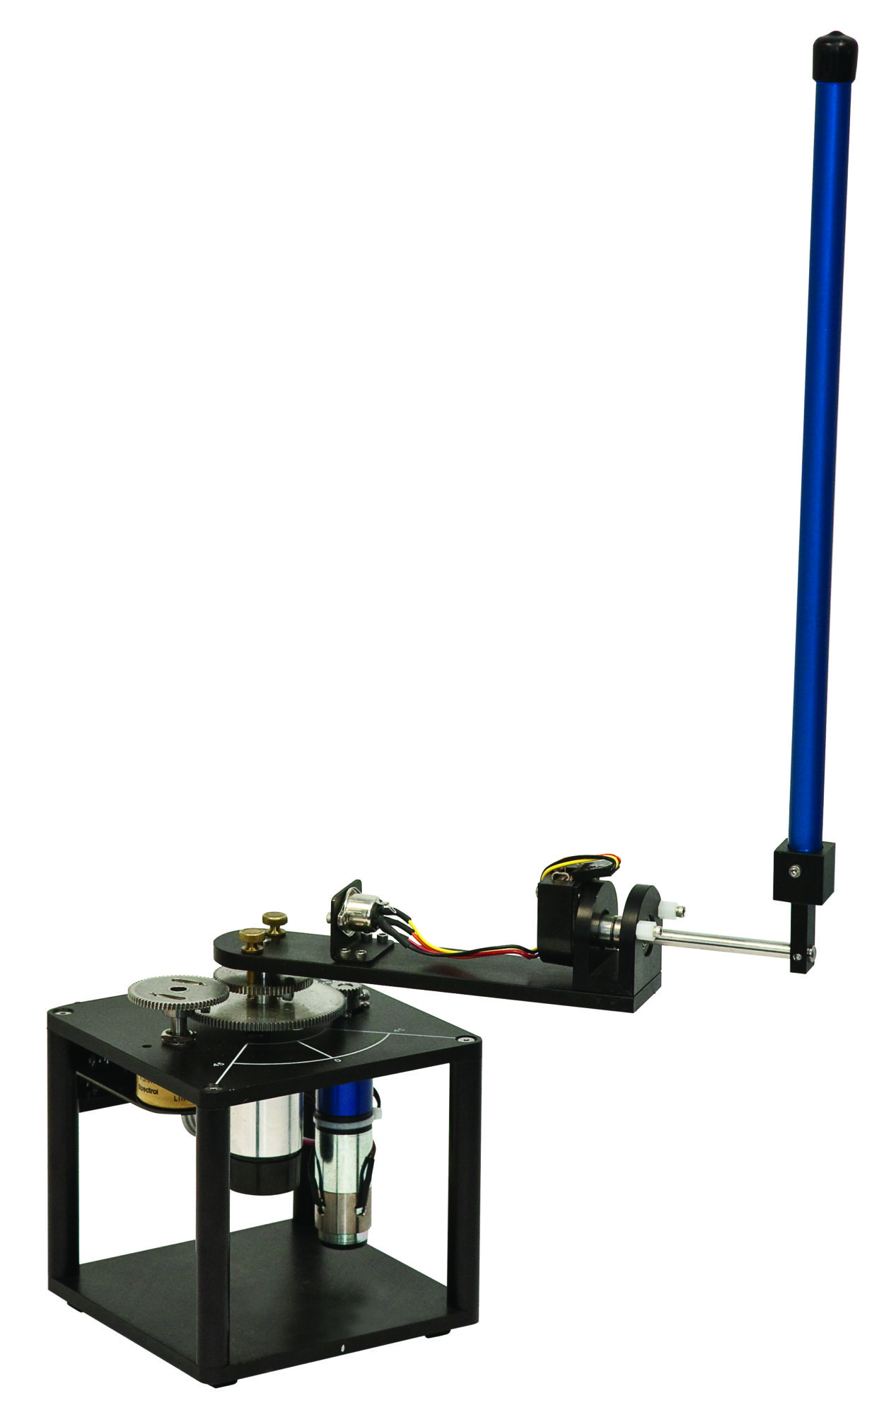(Figure: 1.2.1)

#### Reaction Wheel Inverted Pendulum

* + Using Torque and Counter-Torque of a wheel at the top to keep the pendulum from falling.

(Figure: 1.2.2)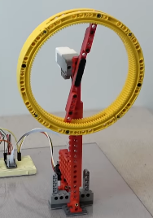

#### Technical Challenges

* Tuning the Pendulum to stay vertical
* Getting pendulum to “swing up” automatically
* Calculating how fast the motor needs to turn based on pendulum angle
* Troubleshooting and making sure sensors give accurate and precise readings

## Customers/markets/economics/applications

### Stakeholders

Stakeholders are the people and organizations who have a stake or say in the actual implementation and review of our proposed system, these include:

• Educators and Academics

• Industrial Training

• Producers of parts and service

### Use

This system will provide an excellent robust teaching tool for its users to grasp and deeply understand the function of a PID loop, which is an essential software and hardware algorithm for many industries.

# ConOps Summary

## System Description

A PID system is a general method for a computer or intelligent system to reduce the error or deviation in a system. Examples include the thermostat in a stove, the cruise control in a car or the gain control on a phone microphone.

This system aims to help display the fundamentals of a PID system in the form of a machine dedicated to allowing the operator to experiment with the tuning and functions behind the algorithm.

It will be constructed from steel and wood, powered by a single motor and a small processor and power supply, portable but robust enough to be installed in semi-permanent use. Weighing between 30 and 50lb, with a tft screen. The system will use a demo PID loop to balance an inverted pendulum and allow user input to control the rates and response of the loop

# System Requirements (Top Level)

## Functional Requirements: (what it does)

| Number | Requirement | Verification |
| --- | --- | --- |
| 1.1 | The system shall have a low power mode in which all components are put into an idle state. | Feature/Test/  Inspection |
| 1.2 | The system shall have an autonomous mode in which the pendulum will balance itself using an integrated PID loop. | Feature/  Demonstration |
| 1.3 | The system shall have a user-control mode in which the turning of potentiometers shall manipulate the constants of the PID loop | Feature/  Demonstration |
| 1.4 | The system shall be self-tensioning. | Feature/  Inspection/Test |
| 1.5 | System modes will be selectable by the user. | Feature/  Demonstration |
| 1.6 | The system shall have a screen capable of displaying the oscillations of the pendulum and the correction curve formed by the PID loop to the user. | Feature/  Inspection/  Demonstration |
| 1.7 | The system shall have a capacitive sensor that detects if the pendulum has come in contact with human skin. | Feature/Test |
| 1.8 | The system shall have an emergency stop. | Feature/Test/  Inspection |
| 1.9 | The system shall have a buzzer or noise making component to warn users of before the pendulum begins to harmonically oscillate into its balanced position. | Feature/  Demonstration |
| 1.10 | The system shall have an embedded fan in the electrical compartment to cool the circuit board and the power supply. | Feature/Test |

## Performance Requirements: (how well it does)

| Number | Requirement | Verification |
| --- | --- | --- |
| 2.1 | System should be reasonably quiet. | Test/  Demonstration |
| 2.2 | The system shall be sufficiently powered using a standard 120 V wall outlet. | Test/Feature |
| 2.3 | The pendulum shall swing up into a start position in under 15 seconds. | Test/  Demonstration |
| 2.4 | Upon sensing a ground due to the touch of human skin, the capacitive sensor in the circuit board shall cut current from reaching the motor in under 200ms. | Test/  Demonstration/  Feature |
| 2.5 | Upon the press of the estop, the system shall cut current from reaching the motor instantly. | Test/Inspection |
| 2.6 | The autonomous mode shall balance the pendulum for the entirety of the duration that the system is in this mode (after the pendulum has been spun up to its starting position). | Test/  Demonstration |
| 2.7 | No component shall not exceed a temperature of 110 degrees Fahrenheit while in normal operation. | Test/Inspection |

## Physical Requirements: (sizes, weight)

| Number | Requirement | Verification |
| --- | --- | --- |
| 3.1 | The pendulum shall weigh between 8 to 13 grams | Inspection |
| 3.2 | The span of the linear track for the pendulum shall be no more than three feet long. | Inspection |
| 3.3 | The display screen shall have color to easily distinguish between the control loop, the current error in the system, and the target value for achieving balance. | Test/  Demonstration/  Inspection |
| 3.4 | The system shall weigh no greater than 50 lbs with the removable legs attached. | Inspection |
| 3.5 | The frame of the assembly shall be made with mild steel. | Inspection/  Feature |
| 3.6 | All electrical components shall be grounded. | Inspection/  Test |
| 3.7 | The pendulum shall be 1.5 feet in length. | Inspection |
| 3.8 | All elements shall operate under their yield stresses and have a factor of safety of 1.5 or greater for embedded components. | Inspection/  Feature |
| 3.9 | All elements shall be under a fatigue strength that allows for a product lifetime of 20 years. | Inspection/  Feature |

## Environmental and Safety Requirements:

| Number | Requirement | Verification |
| --- | --- | --- |
| 4.1 | The wooden base shall be given a varnish finish to improve the longevity of the wood and stop corrosion and thermal cycling damage. | Inspection |
| 4.2 | All fasteners shall be secured from vibration. | Inspection/  Feature |
| 4.3 | The system shall operate in a temperature range from 50 degrees Fahrenheit to 90 degrees Fahrenheit. | Inspection/  Test |
| 4.4 | The electrical compartment in the base shall be to open independently of the system in order to remove any dust that accumulates. | Test/  Demonstration |

## Engineering Standards Applied:

| Number | Requirement | Verification |
| --- | --- | --- |
| 5.1 |  |  |
| 5.2 |  |  |

# 

# Risk Assessments

## Risk Assessment

| Risk Statement | Likelihood | Consequence | | Mitigation | Trigger |
| --- | --- | --- | --- | --- | --- |
| Tech | Cost Schedule |
| Operators can have hair, fingers or extremities caught in pinch points. | 5 | Low | Low | Shields and guards keep hair and fingers away from dangerous areas.  Capacitive and e-stop sensors deactivate loop when out of spec | On touch |
| Operators may become struck by falling pendulum | 1 | Low | Low | Pendulum has a very low weight and a low maximum jerk-speed. | On touch |
| Machine can become damaged by improper tuning | 3 | High | Low | When out of tune PID loops are prone to vibration and oscillation, to mitigate we will   * Program min and max safe values * Build with the understanding that out of tune loops will produce known vibrations | When in use |
| Risk of fire, or total failure | 1 | Low | Low | Well documented internals and an electrical system robust and built to common standards. | All the time. |

# 

# Design Concepts

## Sketches

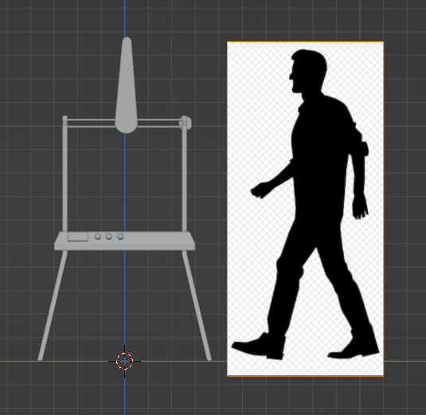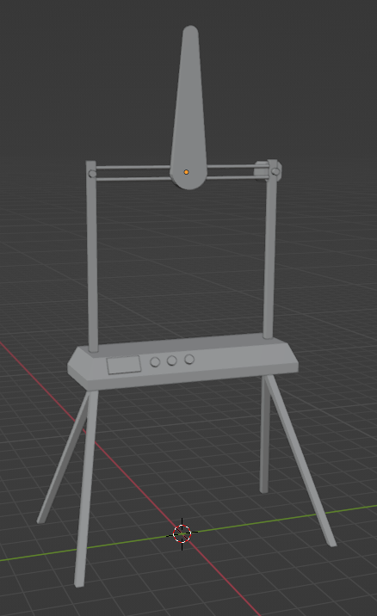

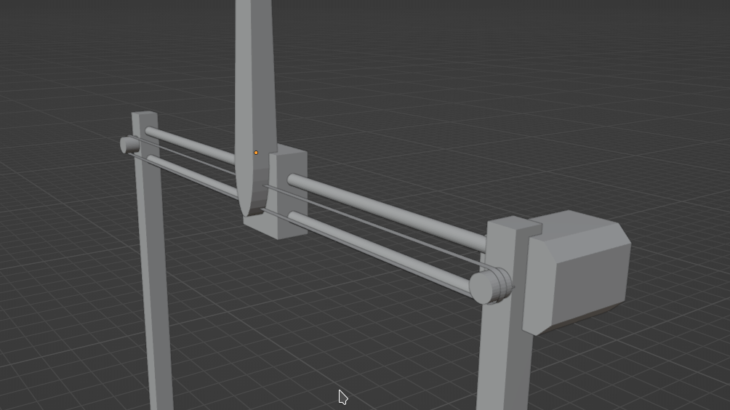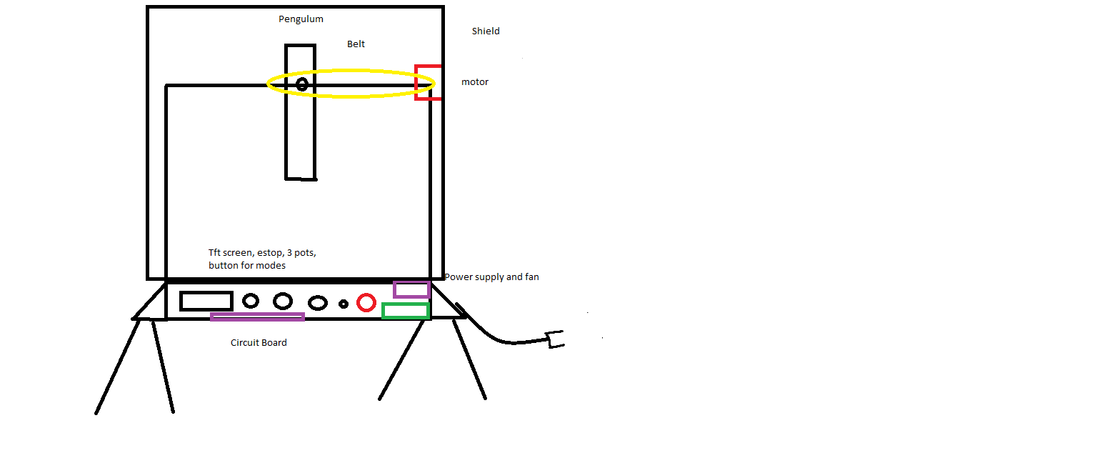

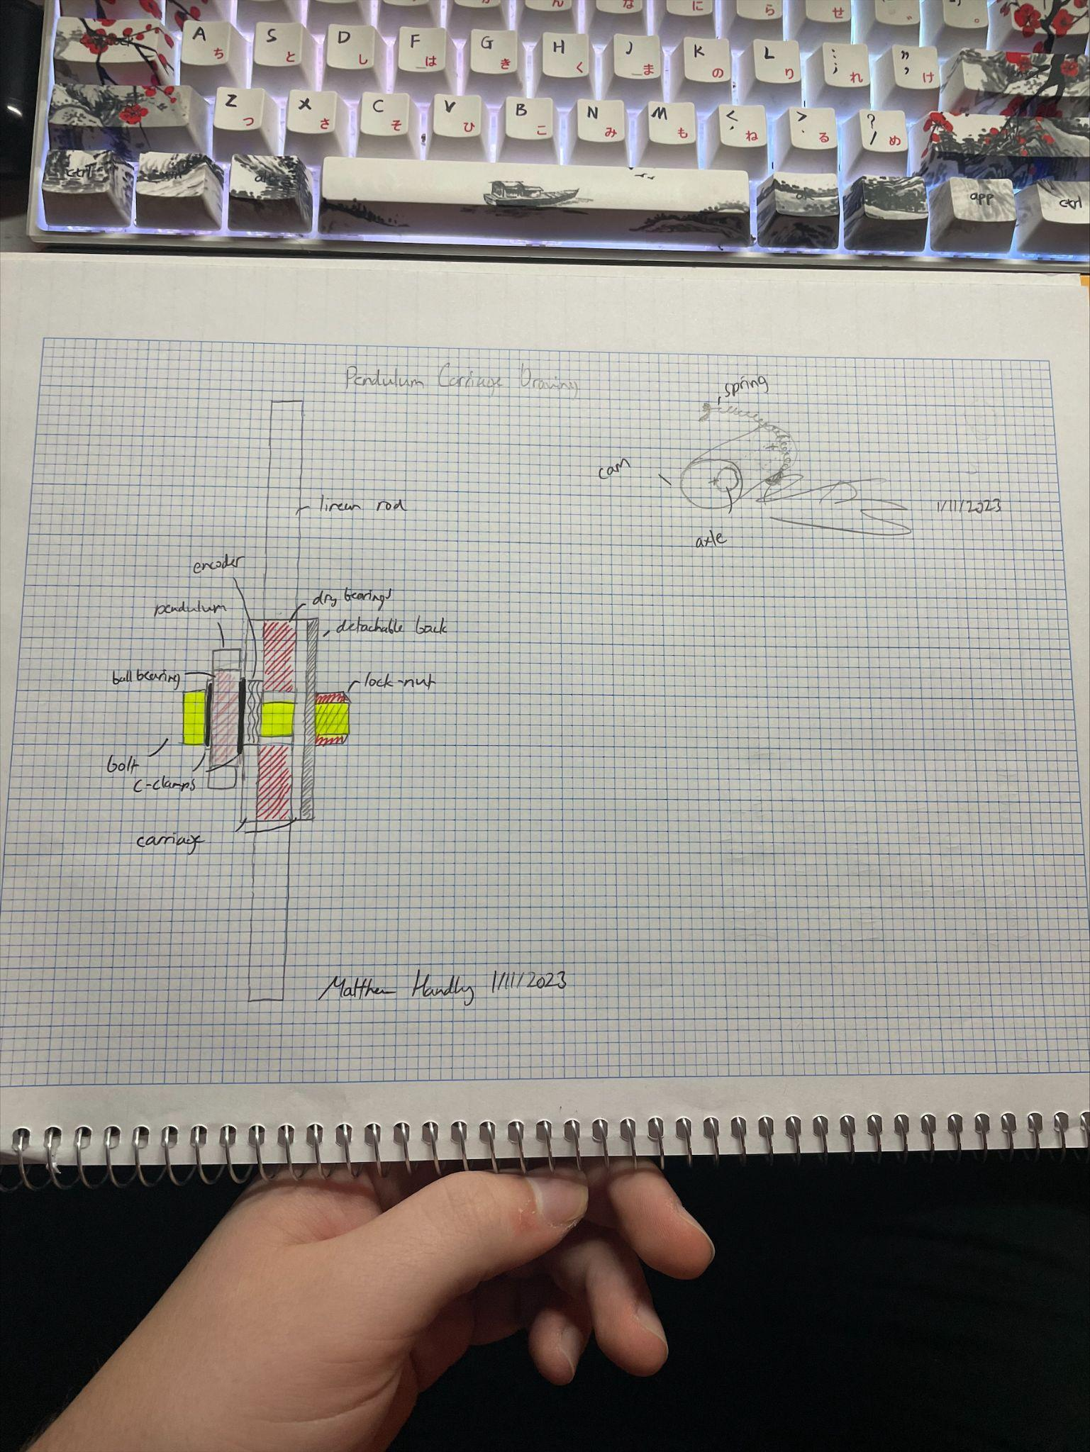 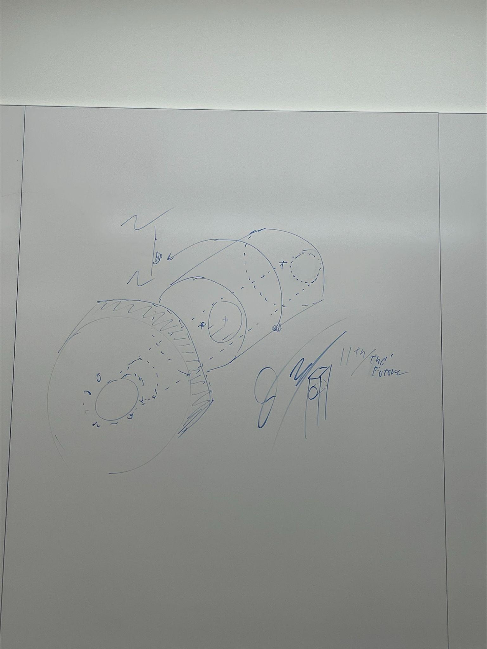

## System Composition Block Diagram

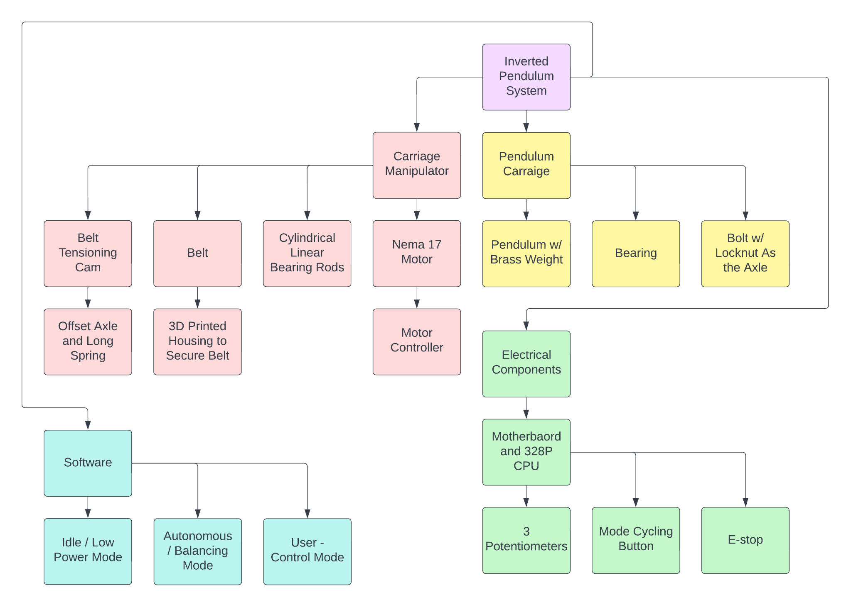

## Flow Chart of Operations

## Health and Safety Design Features:

* Protective shielding around the pendulum’s range of motion to avoid pinch points and physical contact.
* Capacitive e-stop and manual e-stop in case of emergency.
* All electrical components are grounded to prevent dangerous discharge.
* All components shall be ventilated and fan cooled to regulate temperatures.
* Access to embedded components shall be easy to clean the machine and remove dust and debris.

## Used Engineering Standards:

# Task Plan

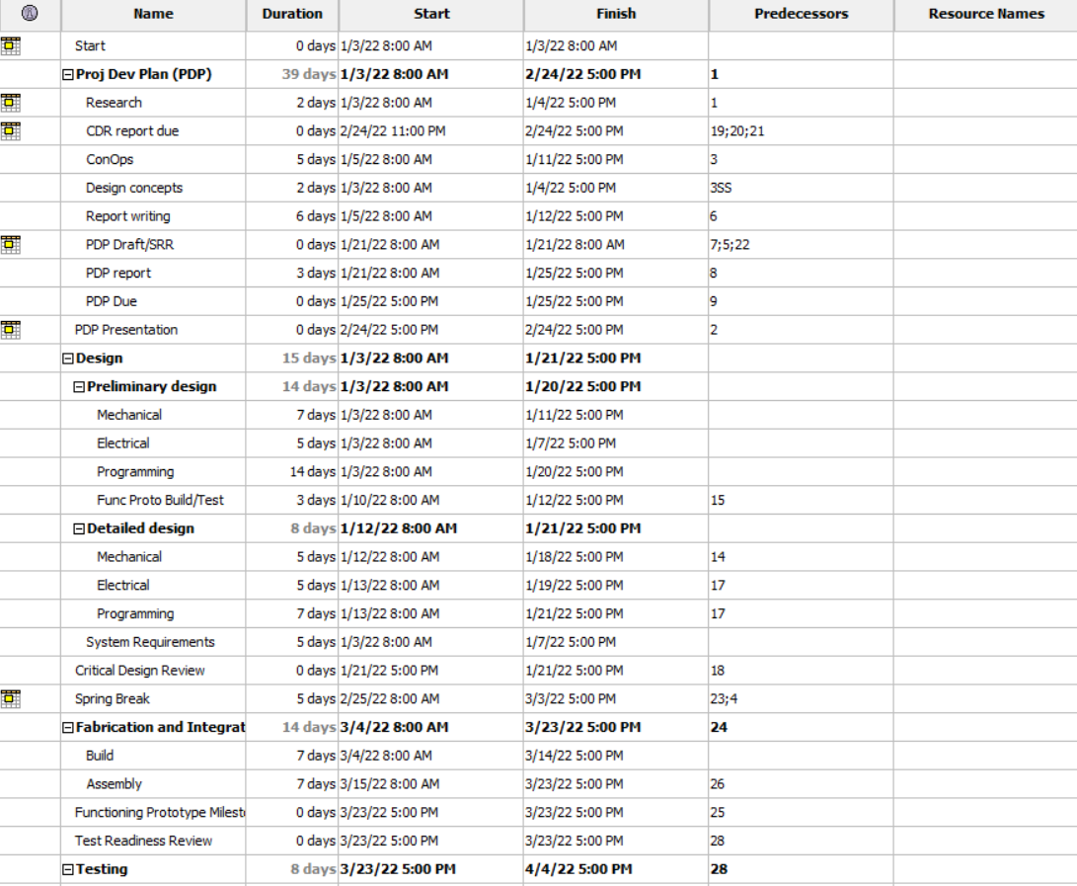

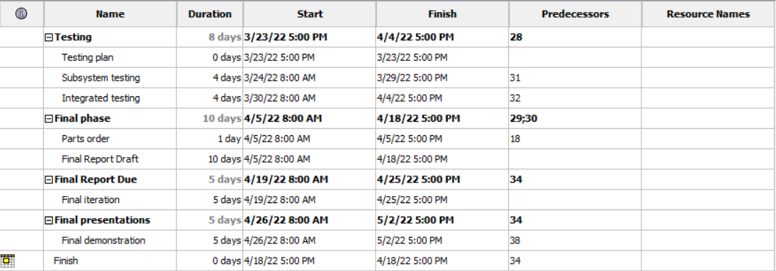

# Budget

# References

Figure (1.2.1) (n.d.). *Rotary Inverted Pendulum*. Quanser. Retrieved January 22, 2023, from https://www.quanser.com/wp-content/uploads/2017/03/ROTPEN-graphics.jpg

Figure(1.2.2) (n.d.). *Lego, Raspberry and Python Project - Reaction Wheel Inverted Pendulum*. (2022, April 16). YouTube. Retrieved January 22, 2023, from <https://youtu.be/WObG2LoSEwQ>